Labtask 3
Students must submit:
- The Unity Scene created for the lab that will be checked in class.
- Video uploaded of the game to a video streaming platform, and the link shared.
- A lab report answers the questions asked in the Vector section.

Project Setup
- Open the existing Unity 2D project that was previously used for the Breakout and Platformer examples.
- Inside the Assets folder, create a new folder named:
- LabTask3
- Inside this folder, create a new Scene and name it:
- PlatformerLabScene
- Open this scene and save your work inside the new folder.
This helps organize the project and avoid creating multiple Unity projects unnecessarily, which saves disk space.

Tilemap Level Recreation
You will be given:
- A sprite sheet containing tiles (Use the Milkshake_Land from the 2d platformer pack I provided in class)
- A reference image of a small platformer level (Don’t draw the red crossed objects)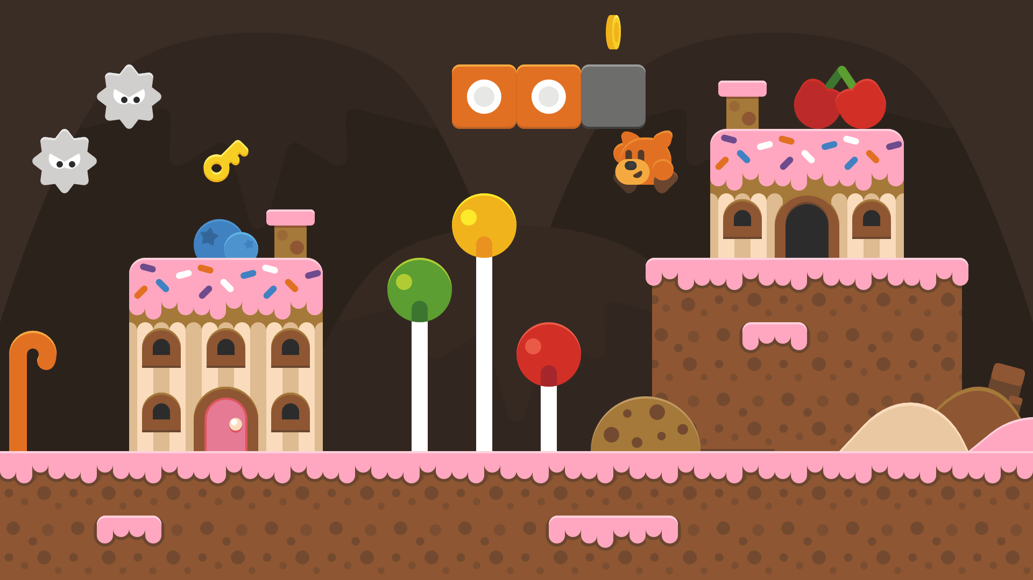
Your task is to:
- Import the sprite sheet into Unity.
- Slice the sprite sheet into individual tiles.
- Create a Tile Palette using these tiles.
- Use a Tilemap to recreate the level shown in the reference image as closely as possible.
- Add appropriate Tilemap Colliders so the player can stand on platforms.

A good video on tile map:
https://www.youtube.com/watch?v=DTp5zi8_u1U

Player Movement and Jump
Create a Player GameObject and add the required components:
- Sprite Renderer
- Rigidbody2D
- Collider
Implement basic player movement and jumping.

Vector Exploration
Observe how movement and jumping use different components of a vector.
- Movement usually modifies Vector2.x.
- Jumping usually modifies Vector2.y.
Answer the following questions in your lab report:
- Why do we modify vector.x for horizontal movement?
- Why do we modify vector.y for jumping?
- What happens if we change both values incorrectly when applying movement?
Explain why separating horizontal movement and vertical movement allows the player to jump while still moving left or right.

Jump Improvement
Modify your jump so that:
- The player jumps up normally
- The player falls faster than they go up
Research and implement a method to achieve this effect.
Hint: This can be done by modifying gravity or downward velocity.

